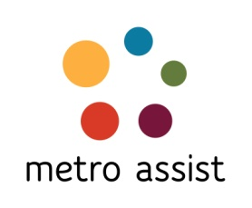
Lvl 2, 59-63 Evaline St Campsie 2194
PO Box 503 Campsie NSW 2194
Tel: 02 9789 3744 I Fax: 02 9718 0236

APPLICATION FOR MEMBERSHIP OF METRO ASSIST INCORPORATED RULE 30(1)
(Incorporated under the Associations Incorporation Act 1984)
ABN 9719621086
I,
(full name of applicant)
of
(address)

Name of the organisation/agency (if applicable)

(occupation)
hereby apply to become a member of the above named incorporated association under the following category:
□ Ethnic organisation member (A)
□ Community organisation member (B)
□ Individual member (C)
In the event of my admission as a member, I agree to be bound by the rules of the association for the time being in force.

Signature of applicant Date

I, a member of the association,
(full name)
nominate the applicant, who is personally known to me, for membership of the association

(Signature of proposer) Date

I, a member of the association,
(full name)
second the nomination of the applicant, who is personally known to me, for membership of the association

(Signature of seconder) Date

