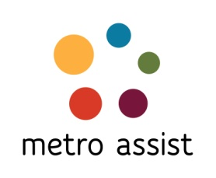
Lvl 2, 59-63 Evaline St Campsie 2194
PO Box 503 Campsie NSW 2194
Tel: 02 9789 3744 I Fax: 02 9718 0236

APPLICATION FOR MEMBERSHIP OF METRO ASSIST LIMITED RULE 8(4)
(Registered under the Corporations Act)
ABN 9719621086 ACN 615 565 869
I,
(full name of applicant)
of
(address)

from …………
Name of the organisation/company/agency (for corporate members)

(occupation)
hereby apply to become a member of Metro Assist Limited under the following category:
□ Individual member
□ Corporate Member
In the event of my admission as a member, I agree to be bound by the rules of the company for the time being in force.

Signature of applicant Date

I, a member of the company,
(full name)
nominate the applicant, who is known to me, for membership of the association

(Signature of proposer) Date

I, a member of the company,
(full name)
second the nomination of the applicant, who is known to me, for membership of the company.

(Signature of seconder) Date

